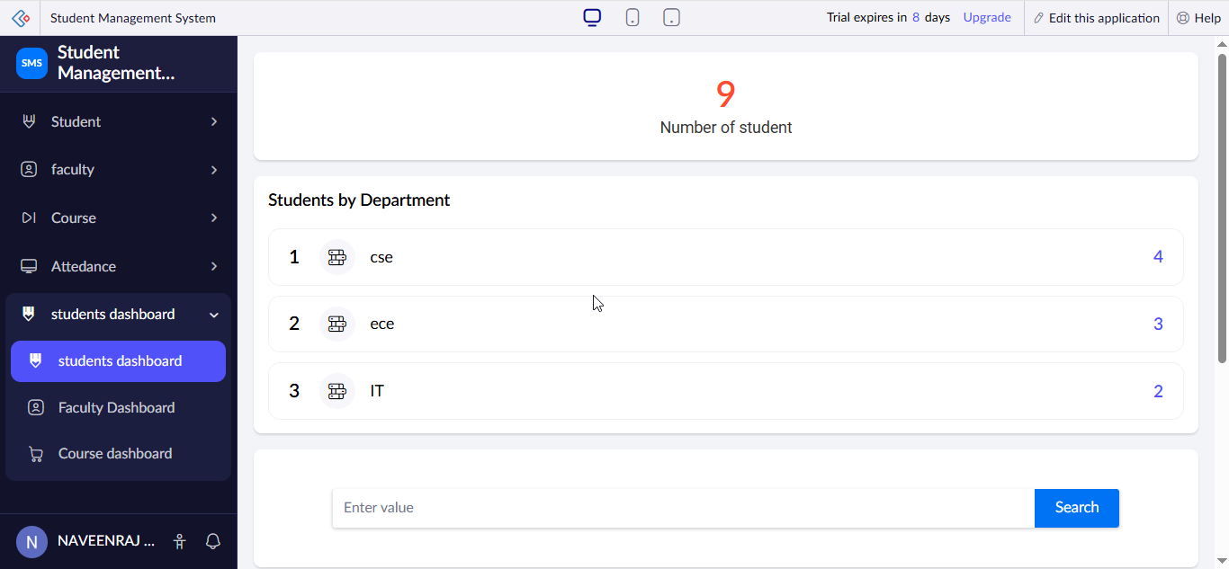Student Dashboard Summary
Dashboard Overview
The Student Dashboard provides a comprehensive overview of student information maintained in the Student Management System. It displays the total number of students, department-wise distribution, year-wise statistics, and student demographic details. The dashboard enables users to monitor student records efficiently and gain insights through visual reports and charts.
Purpose
The purpose of this dashboard is to simplify student data management and provide quick access to important statistics for academic monitoring and decision-making.
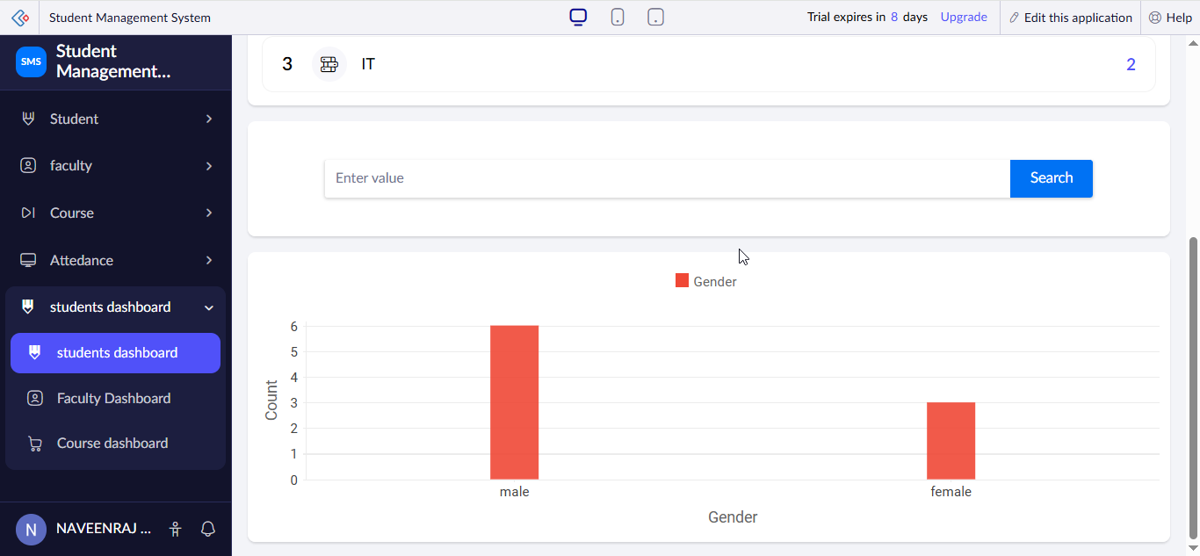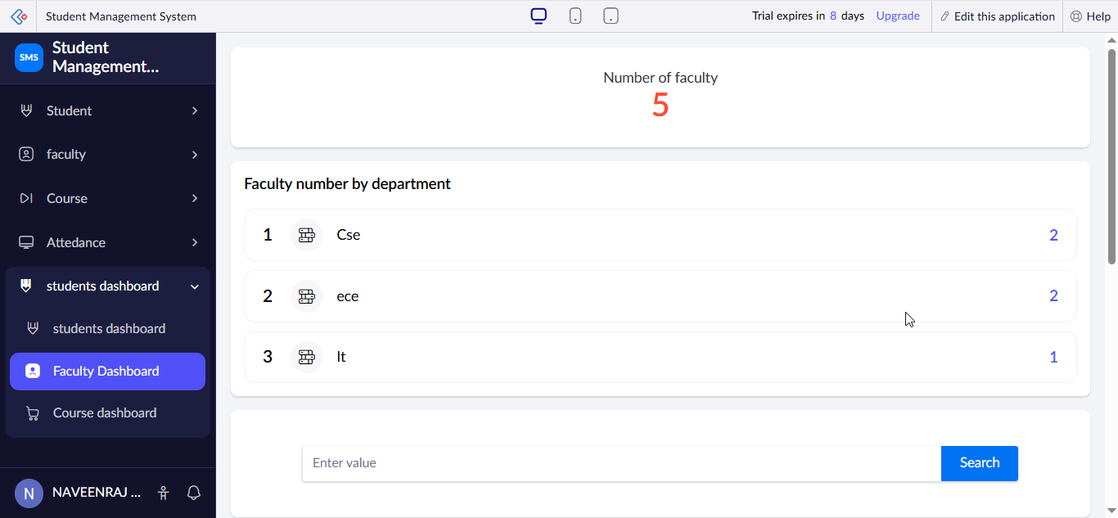

Faculty Dashboard Summary
Dashboard Overview
The Faculty Dashboard presents faculty-related information stored in the Student Management System. It includes faculty count, department-wise faculty distribution, and faculty reports. This dashboard helps administrators monitor faculty records and analyze staffing information effectively.
Purpose
The purpose of this dashboard is to provide a centralized view of faculty information and support efficient management of faculty records.

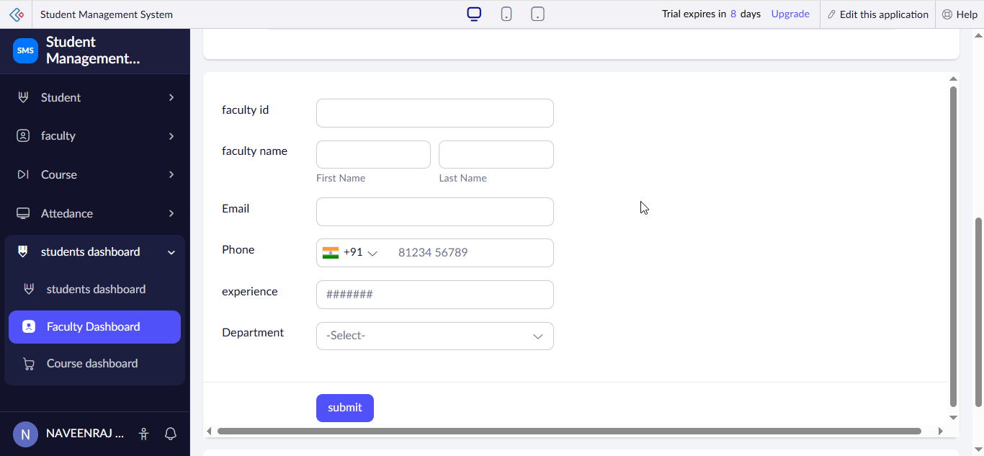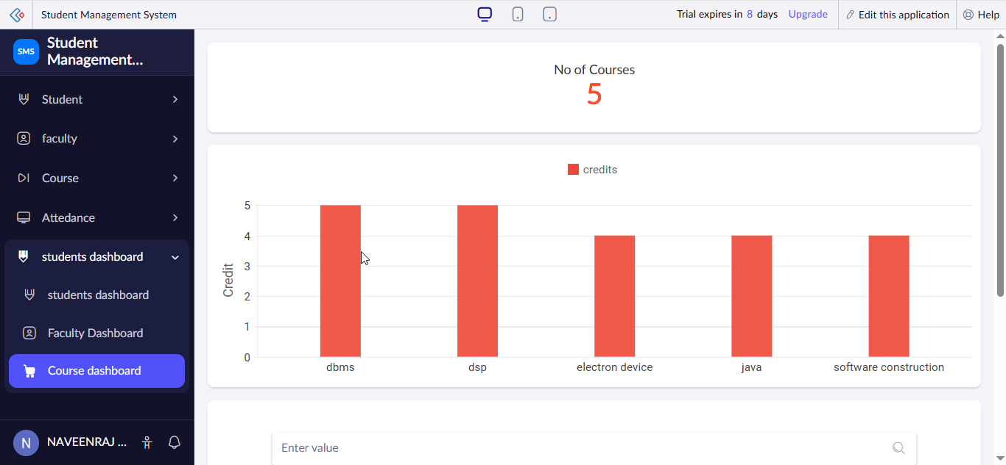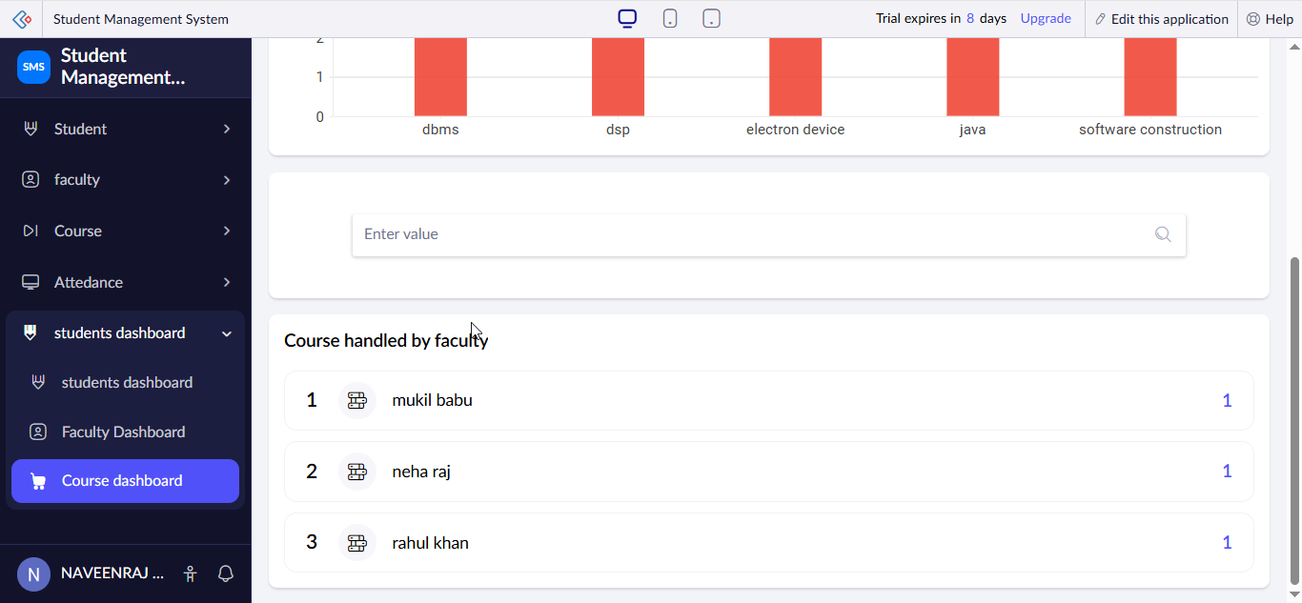

Course Dashboard Summary
Dashboard Overview
The Course Dashboard provides an overview of courses offered within the institution. It displays course statistics, department-wise course distribution, and course-related reports. The dashboard helps users understand academic offerings and track course information efficiently.
Purpose
The purpose of this dashboard is to organize and visualize course data, enabling effective academic planning and management.

